**Formative Assignment __**

|  |  |
| --- | --- |
| Module Name | Web Development Using Platforms |
| Course Name | Bachelor’s Degree in Software Engineering |
| Assignment Title | Develop an Application |

|  |  |
| --- | --- |
| Learner Name | Francis Roel L. Abarca |

|  |
| --- |
| Learner declaration |
| I certify that the work submitted for this assignment is my own and research sources are fully acknowledged.  Student signature: Date: 3/31/23 |

**Trainer--- University training, SSG training,**

**Content development**

**Scope of this assignment**

1. To implement a database-driven application, right-click on previous Feedback MVC project -> create a new Liferay service builder with package path "com.liferay.docs.feedback". Use the namespace as FB.
2. Create an entity as a local service in service.xml with entity name Feedback.
3. Define the columns as the following. feedbackID, feedbackDate, feedbackMessage, feedbackSubject, companyID, groupID, userID.
4. In service.xml, define the order of feedback entity by ascending feedbackId.
5. In service.xml, define Service Entity Finder Methods for GroupId, CompanyId and feedbackText cloumns.
6. Build your service. If build success, check the service Builder generates classes and interfaces belonging to the persistence layer, service layer, and model layer.
7. Expose the Finder in the Service Layer *LocalServiceImpl. Implement a service layer for Feedback entity and create a method "addFeeback" that adds Feedbacks to the database.
8. Update controller (your portlet class) action method to handle the Feedback form.
9. Update view.jsp page to display all the feedback.
10. Build your service application, deploy your portlet, and try adding some Feedback for your portal.

**Task Wise Solutions**

**To implement a database-driven application, right-click on previous Feedback MVC project -> create a new Liferay service builder with package path "com.liferay.docs.feedback". Use the namespace as FB.**

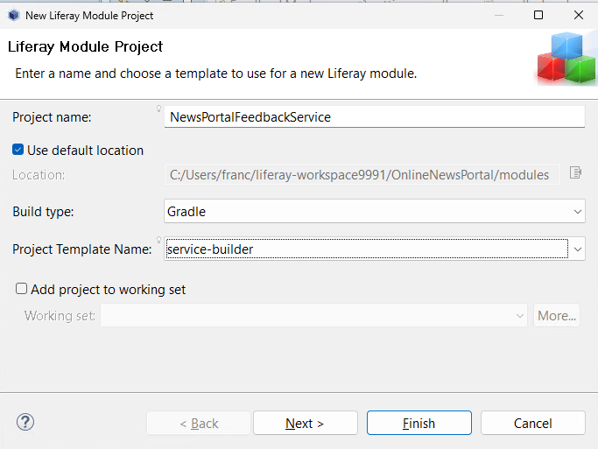

**Create an Entity as a local service in Service.xml with the entity name Feedback.** 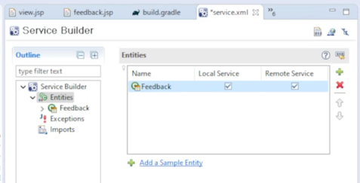

**After that, define the colums as the following:**

**Define the order of feedbackId by ascending.**

****

**Inside service.xml, define the Finder methods for feedback_message, groupID and companyID.**

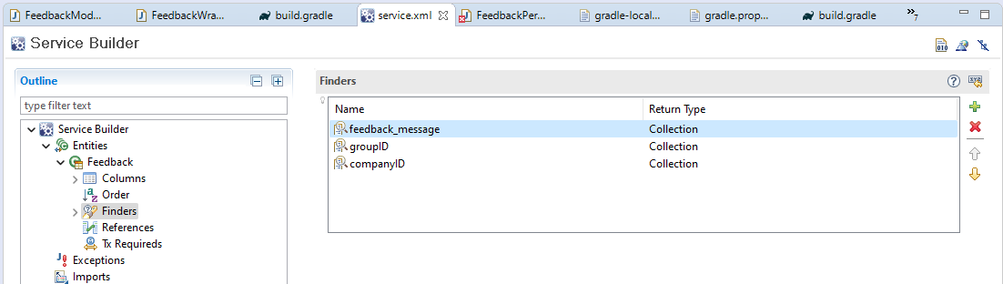

**Build your service then check the service builder and generate classes belonging to the persistence layer, service layer and model layer.**

**Go to FeedbackPersistenceImpl.java inside the Service layer then add the following method for it to be connected to the database.**

**Then add these lines of code inside:  
findBygroupID**

@Override

**public** List<Feedback> findBygroupID(**long** groupID) {

**return** findBygroupID(

groupID, QueryUtil.***ALL_POS***, QueryUtil.***ALL_POS***, **null**);

}

@Override

**public** List<Feedback> findBygroupID(**long** groupID, **int** start, **int** end) {

**return** findBygroupID(groupID, start, end, **null**);

}

@Override

**public** List<Feedback> findBygroupID(

**long** groupID, **int** start, **int** end,

OrderByComparator<Feedback> orderByComparator) {

**return** findBygroupID(groupID, start, end, orderByComparator, **true**);

}

**findBycompanyID**

@Override

**public** List<Feedback> findBycompanyID(**long** companyID) {

**return** findBycompanyID(

companyID, QueryUtil.***ALL_POS***, QueryUtil.***ALL_POS***, **null**);

}

@Override

**public** List<Feedback> findBycompanyID(**long** companyID, **int** start, **int** end) {

**return** findBycompanyID(companyID, start, end, **null**);

}

@Override

**public** List<Feedback> findBycompanyID(

**long** companyID, **int** start, **int** end,

OrderByComparator<Feedback> orderByComparator) {

**return** findBycompanyID(companyID, start, end, orderByComparator, **true**);

**findByfeedback_message**

@Override

**public** List<Feedback> findByfeedback_message(String feedback_message) {

**return** findByfeedback_message(

feedback_message, QueryUtil.***ALL_POS***, QueryUtil.***ALL_POS***, **null**);

}

@Override

**public** List<Feedback> findByfeedback_message(

String feedback_message, **int** start, **int** end) {

**return** findByfeedback_message(feedback_message, start, end, **null**);

}

@Override

**public** List<Feedback> findByfeedback_message(

String feedback_message, **int** start, **int** end,

OrderByComparator<Feedback> orderByComparator) {

**return** findByfeedback_message(

feedback_message, start, end, orderByComparator, **true**);

}

**Update your controller (Portlet class)’s action method to handle the Feedback form.**

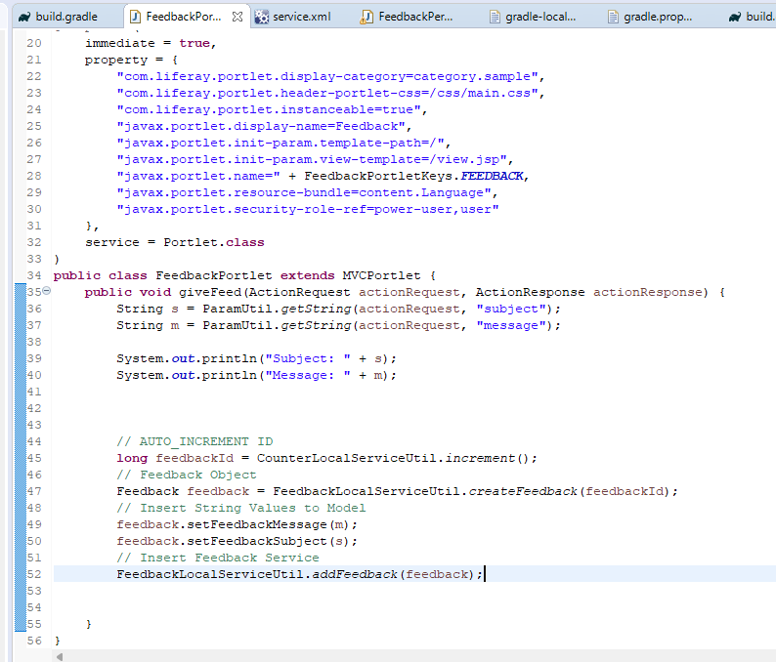

**Update view.jsp page to display all the feedback.**

**Build the service application, deploy the portlet and test the feedback page on your portal.**



